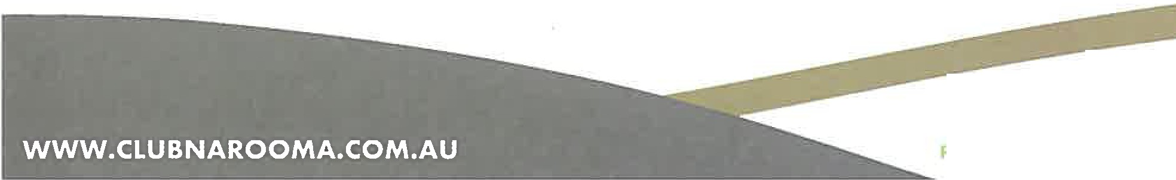

Narooma Sporting & Services Club Ltd
ABN 82 000 997 286

88 Princes Hwy, Narooma NSW 2546
02 4476 2135 r 02 44761486 info@naroomaclub.net.au

President's End of Year Update June 2

My fellow Members,

One financial year ends and a new financial year starts. On behalf of the board, I am pleased to announce that the company has finished well ahead of the 2020 - 2021 budget and once we have audited figures the results will be announced.

My last report to members indicated the capital works that were planned to be undertaken from January 2021. I must stress here that we have experienced some delays which are outside of our control and the latest Covid lockdown is not helping as material from Sydney and other states has been delayed. However, progress is being made.

The following is being undertaken or has been completed.

Club Narooma

- Storage shed has been constructed alongside the rear BBQ area. Complete.
- The sign at the front of the club which holds the badge draw amount will be replaced. The current sign is full of rust and about to fall down. Waiting for delivery. Due October,
- A tender has been released to expand the existing gaming area so all machines will be at 1.5 metres between machines. The contract has been awarded to Edwards Constructions and work will begin in June and completed by September.
- The bowlers' toilets attached to the green keeper's shed have been renovated.
- An industry architect has been appointed to draw up plans to refurbish the Montague Room. Final plans and costings due August.
- Plans have been drawn up to provide the bowlers with new locker rooms adjacent to the green keeper's shed. This work is a variation to the Edwards Contract and is underway.
- The cool room and freezer will be expanded due to the increase in trade especially at holiday time. Near completion.

Club Dalmeny

This is where the company has had a major delay which is outside of our control. However, we are committed to Stage 1 which will be the outside deck and new entrance ramp.

- The building committee had its final meeting with the architect on 5th July to review and adjust the final plans for a staged development. Completed plans are now due by the end of July.
- Once we have a set of agreed plans they will be put on display at both Clubs and lodged with council to obtain a DA. Also, an information meeting will be held at Club Dalmeny to explain the staged process. We are working to have a DA by the end of August or early September at the latest.
- The current timetable was to have the outside deck constructed by Christmas 20 1 but this has been put back to the first quarter 2022.
- A coffee machine is planned to be installed at Club Dalmeny by the end of August.

Awards

The Club received an award from Clubs New South Wales, in the category of the Clubs and Community Awards for its efforts in supporting the community during the 2020 bush fires. On behalf of the board, congratulations to Tony Casu, the Senior Management and Staff for a job well done.

Also, Tony Casu received an award in the category of the Heart of the Community. Again, well done

Future

Our long-term future depends on Covid 19 and we may have a clearer picture by December 2021. The planning committee has updated the Strategic and Business Plan to take the company to 2024. It includes:

- Managing company business after Covid 19.
- Continuing to monitor the performances of Club Narooma and Club Dalmeny.
- Reducing the company's reliance on gaming.
- Investigating diversification.
- Managing the company's loan.
- Encouraging members, both male and female to become potential directors.
- Continuing to support the community.
- Continuing to work with Federal, State and Local Government.
- Managing the Capital Works program

All are critical to the long-term financial stability and growth of the NSSC.

Again, on behalf of the board I would like to thank our CEO, senior staff, duty managers and staff for their efforts and support in achieving our results to date.

I would also like to take this opportunity to thank all the Directors for their support and input.

In closing, based on our current results and future direction, the company has never been in such a strong financial position since 2004 and this is due to the teamwork at all levels.

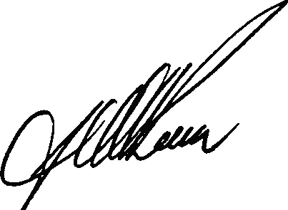Graliam A. Reeve President
Regards,
Narooma Sporting and Services Club Limited On behalf of the Board of Directors
graham@clubnarooma.com.au 0457 750 677

