We understand that members may not be happy with our decisions and we have not taking them lightly. In the case of Club Dalmeny, three months ago we as a board were committed to proceed, as detailed above, and due to the quotes received being considerably more than was budgeted in early 2022 due to building material and staff costs increases, we cannot proceed at this stage.

IRT - The Executive have met with IRT twice to determine if a joint venture would be in the best interests of the club and the members. I cannot share with you our discussions at this stage but we hope to make a decision recommending to proceed or not with IRT during March 2023. We will then be able to release details of the proposed development if we were to proceed to the next stage. Please be aware that any recommendation to proceed will be put to the members for a vote at a general meeting where members will have the final say.

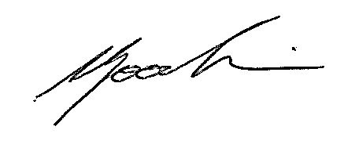
Barry Goodwin
President
16-2-2023
On behalf of the NSSC Board

